STUDY OF SYMMETRIC KEY - DES & AES

AIM :- To Study and Implement Symmetric Key Cryptography using DES & AES Algorithm in Python.

ALGORITHM OF (DES) :-
- Import DES module.
- Create a secret key and pad the message to match the block size.
- Encrypt the plain text.
- Decrypt the cipher-text.
- Display the results.
PROGRAM :- !pip install pycryptodome from Crypto.Cipher import DES from Crypto.Util.Padding import pad, unpad key = b'12345678' cipher = DES.new(key, DES.MODE_ECB) plaintext = input("Enter message: ") padded_text = pad(plaintext.encode(), DES.block_size) encrypted_text = cipher.encrypt(padded_text) print("Encrypted Text:", encrypted_text) decrypted_text = unpad(cipher.decrypt(encrypted_text), DES.block_size) print("Decrypted Text:", decrypted_text.decode())

Output:-
Enter message: hello
Encrypted Text: b'\x9a\x1f\x8b\x9e\x9e\x1f\x8b\x9e'
Decrypted Text: hello

ALGORITHM OF (AES) :- 1. Import AES module.
- Create a 16-byte secret key and pad the message.
- Encrypt and then decrypt using AES.
- Display the output.

PROGRAM:- from Crypto.Cipher import AES from Crypto.Util.Padding import pad, unpad key = b'thisismysecretky' # 16-byte key for AES-128 cipher = AES.new(key, AES.MODE_ECB) plaintext = input("Enter message: ") padded_text = pad(plaintext.encode(), AES.block_size) encrypted_text = cipher.encrypt(padded_text) print("Encrypted Text:", encrypted_text)
decrypted_text = unpad(cipher.decrypt(encrypted_text),
AES.block_size) print("Decrypted Text:", decrypted_text.decode())

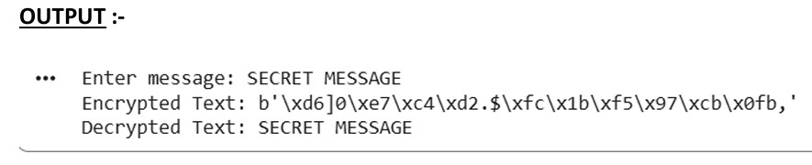 CONCLUSION :- In symmetric key cryptography, the same key is used for both encryption and decryption. DES and AES are two important symmetric algorithms, with AES being more secure and faster due to its larger key size and modern design.

